High ED Utilization (3+) with Low Resource Use with Additional Labs

Call:

glm(formula = High.ED.Utilization.3.Indicator ~ Age.Group + Problem.Count +

CCC.Count + CCC.Congenital + CCC.CVD + CCC.GI + CCC.Hem.Imm +

CCC.Malignancy + CCC.Metabolic + CCC.Neonatal + CCC.Neuromuscular +

CCC.Renal + Public.or.Private.Metric + Holiday.Indicator +

Acute.URI.DX + Long.Term.Drug.Therapy.DX + Nausea.and.Vomiting.DX +

Prior.ED.Visit.Count.Orig + Gender + Major.Region + Race.and.Ethnicity.Group,

family = binomial(logit), data = EDPredictorsLowusePCLab.2016.df)

Deviance Residuals:

Min 1Q Median 3Q Max

-2.4647 -0.3599 -0.2027 -0.1068 3.0587

Coefficients:

Estimate Std. Error z value Pr(>|z|)

(Intercept) -15.14399 892.45988 -0.017 0.986461

Age.Group1 thru 3 years -1.78692 0.29733 -6.010 1.86e-09 ***

Age.Group13 years or more -3.26329 0.62234 -5.244 1.58e-07 ***

Age.Group3 thru 11 months -0.73946 0.29765 -2.484 0.012979 *

Age.Group4 thru 12 years -2.29957 0.34067 -6.750 1.48e-11 ***

Problem.Count 0.08203 0.02764 2.967 0.003006 **

CCC.Count 1.22476 0.50145 2.442 0.014588 *

CCC.Congenital -3.36482 0.92680 -3.631 0.000283 ***

CCC.CVD -1.74002 0.68450 -2.542 0.011022 *

CCC.GI -1.21575 0.82104 -1.481 0.138673

CCC.Hem.Imm -2.13749 0.78259 -2.731 0.006309 **

CCC.Malignancy 1.79885 0.84384 2.132 0.033028 *

CCC.Metabolic -17.91645 623.28837 -0.029 0.977068

CCC.Neonatal -1.60854 1.00909 -1.594 0.110924

CCC.Neuromuscular -1.09859 0.68772 -1.597 0.110170

CCC.Renal -3.09122 0.95387 -3.241 0.001192 **

Public.or.Private.MetricPublic 0.01516 0.45122 0.034 0.973207

Public.or.Private.MetricUnavailable 2.06005 0.68748 2.997 0.002731 **

Holiday.Indicator 0.99924 0.43309 2.307 0.021041 *

Acute.URI.DX 0.32365 0.22097 1.465 0.143016

Long.Term.Drug.Therapy.DX -0.41541 0.24730 -1.680 0.093003 .

Nausea.and.Vomiting.DX -0.90507 0.46520 -1.946 0.051708 .

Prior.ED.Visit.Count.Orig 0.83808 0.06568 12.761 < 2e-16 ***

GenderM -0.43234 0.19476 -2.220 0.026426 *

Major.RegionLocal -3.82435 0.87047 -4.393 1.12e-05 ***

Major.RegionNational -18.78269 2641.56605 -0.007 0.994327

Major.RegionRegional -19.44602 1545.36508 -0.013 0.989960

Major.RegionUnknown -18.51541 4313.53041 -0.004 0.996575

Race.and.Ethnicity.GroupBlack or African American 16.77297 892.45989 0.019 0.985005

Race.and.Ethnicity.GroupHispanic or Latino 17.30185 892.45988 0.019 0.984533

Race.and.Ethnicity.GroupOther 16.19133 892.45987 0.018 0.985525

Race.and.Ethnicity.GroupWhite 17.16612 892.45999 0.019 0.984654

---

Signif. codes: 0 ‘***’ 0.001 ‘**’ 0.01 ‘*’ 0.05 ‘.’ 0.1 ‘ ’ 1

(Dispersion parameter for binomial family taken to be 1)

Null deviance: 1277.82 on 2019 degrees of freedom

Residual deviance: 810.02 on 1988 degrees of freedom

AIC: 874.02

Number of Fisher Scoring iterations: 17

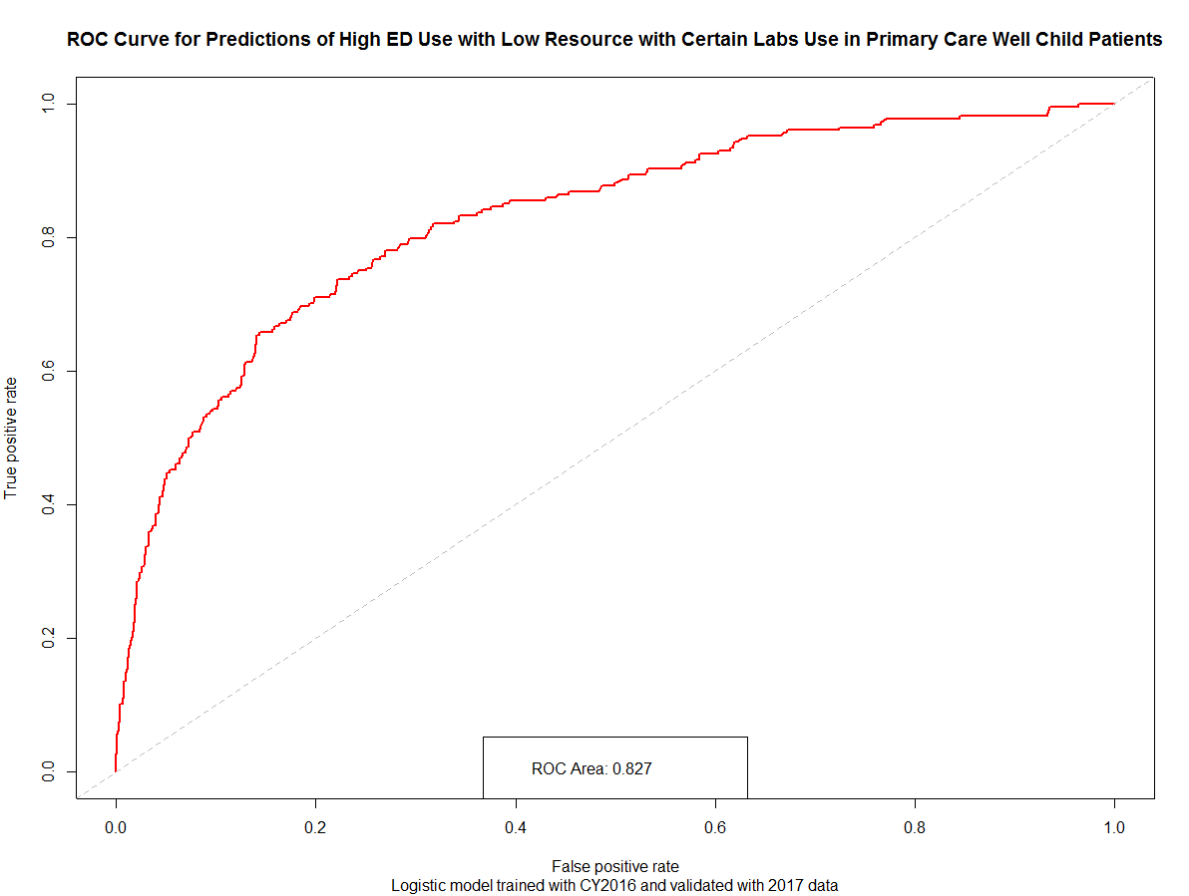

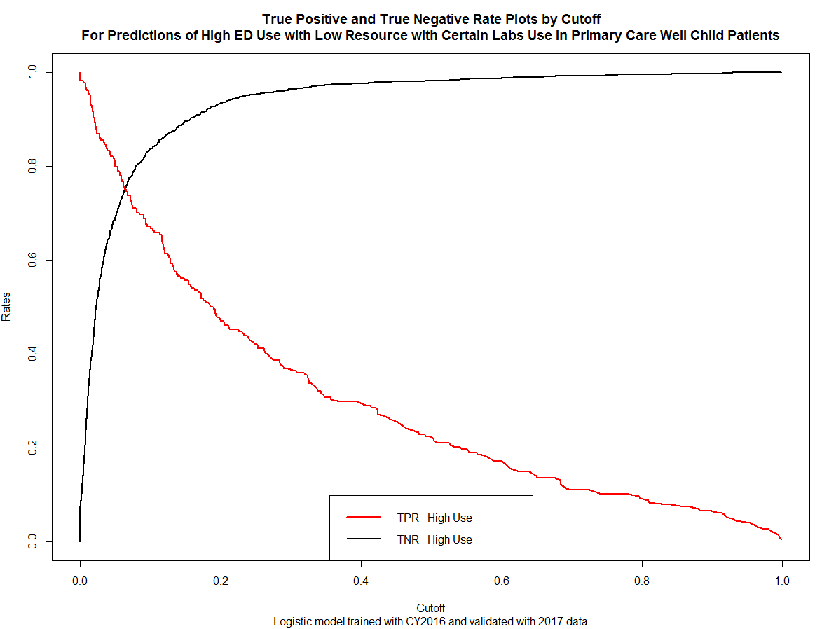

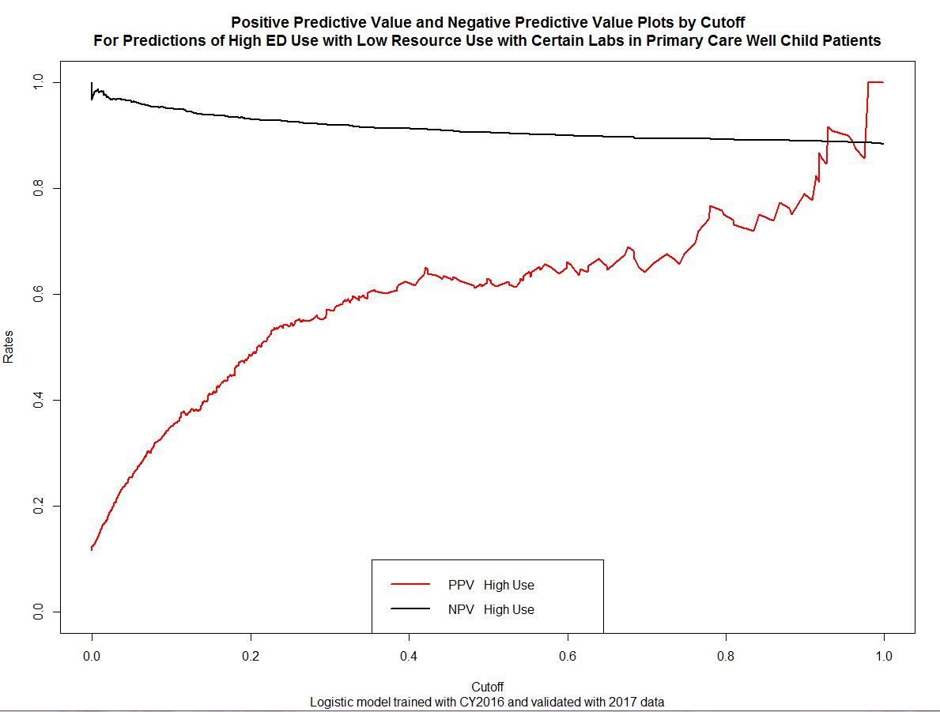

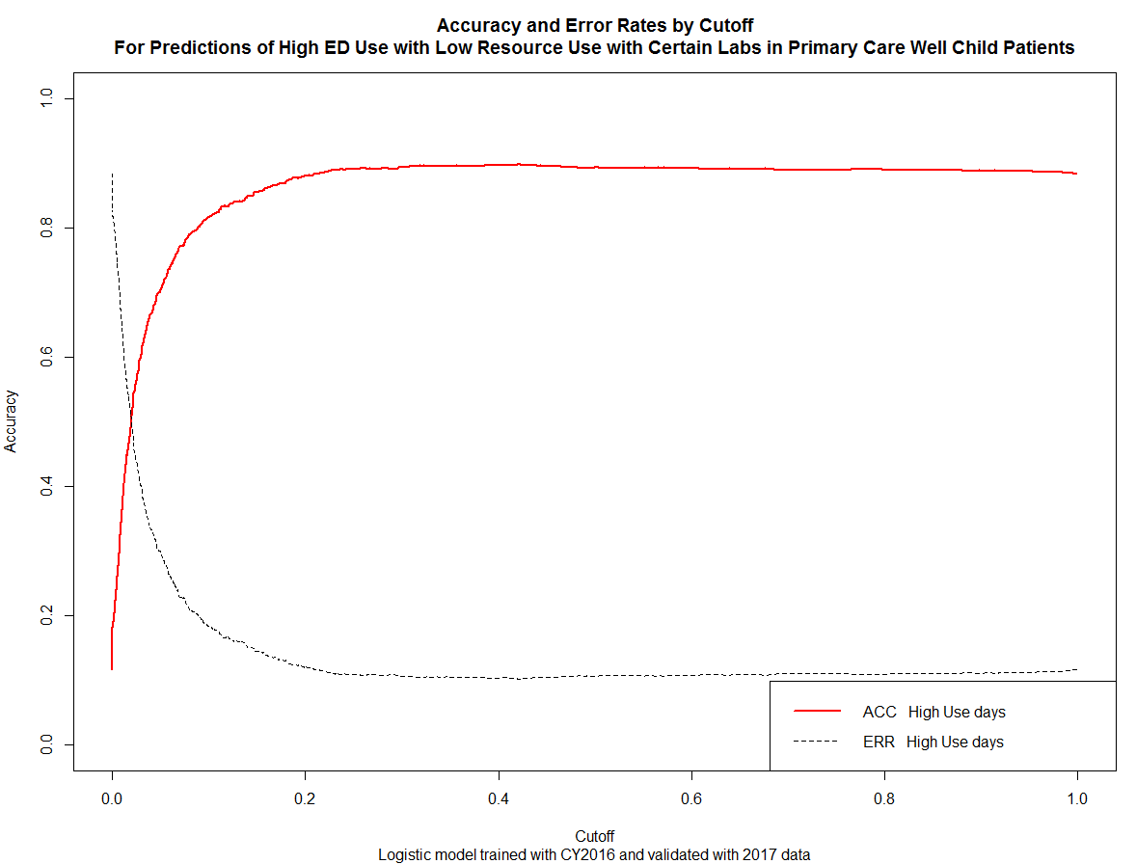

Counts compared to original (no labs at all):

|  |  |  |  |
| --- | --- | --- | --- |
|  | Total Patients | Count of Patients with 3+ Visits | Visits |
| 2016 Orig | 1626 | 49 | 165 |
| 2016 with Labs | 1674 | 55 | 194 |
| 2017 Orig | 1543 | 60 | 205 |
| 2017 with Labs | 1586 | 67 | 228 |